|  |  |
| --- | --- |
| Verticurl LLC |  |

Prepared for AIA

Automated Marketing

Topic: Vitality Eloqua Integration

Date: 28 January 2015

Version: 1.0

Version History:

|  |  |  |  |
| --- | --- | --- | --- |
| Version | Date | Description | Modifier |
| 0.3 | 27 January 2015 | Presentation to AIA | Kenneth Goh, Verticurl |
| 0.4 | 28 January 2015 | Adjustments post meeting | Kenneth Goh, Verticurl |

Contents

1. Objectives of the document 3

2. Requirements 3

2.1. High-level Architectural Diagram 3

2.2. Source Systems 4

2.3. SFTP 8

2.4. Websphere 8

2.5. Eloqua 9

3. Project Plan 14

# Objectives of the document

The objective of this document is to document the implementation approach for integration between Vitality (JV and VAS) systems and Eloqua.

# Requirements

## High-level Architectural Diagram

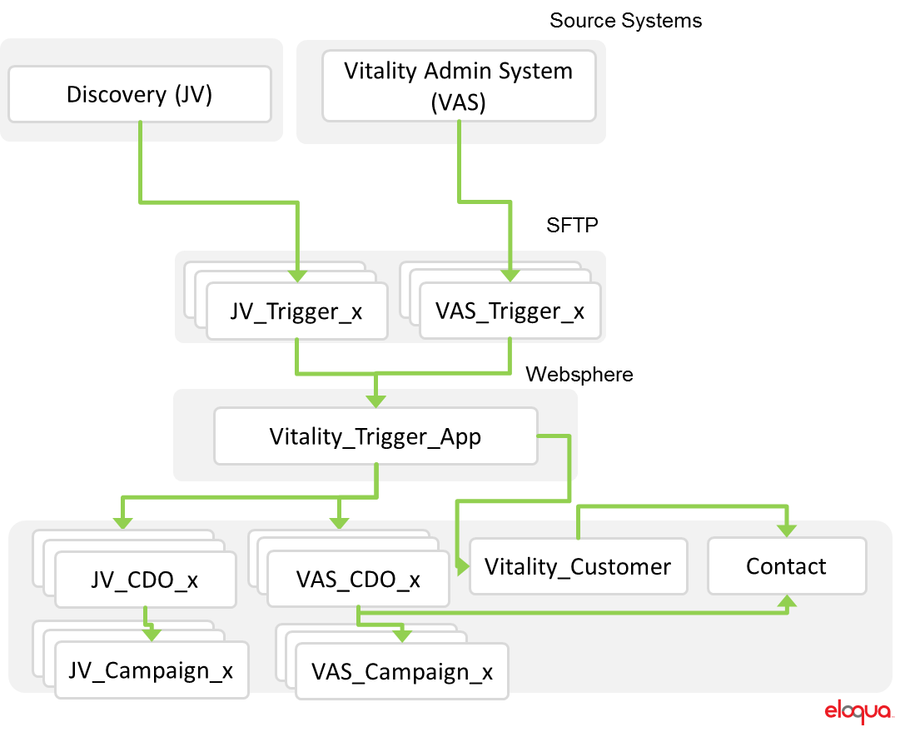

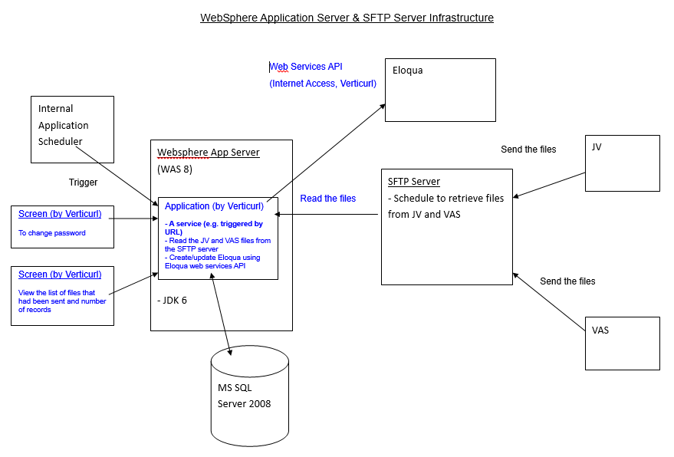

Overview  
For the purpose of this integration, please pay attention to the objects enclosed in the red dotted-line box.

The objective of the integration is to send trigger-based information from JV and VAS to Eloqua. Upon receiving the information, Eloqua places the contacts who qualify for the trigger into the respective trigger campaigns.

## Source Systems

Discovery (JV)  
JV would be sending a total of 30 files to the SFTP server. These files contain the information required for Eloqua to perform the trigger-based email.

Below table documents the general format of each file.

|  |  |
| --- | --- |
| **Encoding** | UTF-8 |
| **File Format** | [Country Code]-[Category] -[Date] |
| **File Type** | CSV |

Below table documents the layout of each file.

|  |  |  |
| --- | --- | --- |
| **No.** | **Name and purpose (high-level)** | **File Structure and Sample Object** |
|  | HK-ENGAGEMENT_REMINDER1-20150128040046 | https://www.dropbox.com/s/m0mk74a2oceffmc/Screenshot%202015-02-10%2010.50.02.png?dl=0 |
|  | HK-ENGAGEMENT_REMINDER2-20150128040046 | https://www.dropbox.com/s/ydljqtli4vmogu5/Screenshot%202015-02-10%2010.50.54.png?dl=0 |
|  | HK-ENGAGEMENT_REMINDER3-20150128040046 | https://www.dropbox.com/s/wmzov79w6jr0i2e/Screenshot%202015-02-10%2010.51.38.png?dl=0 |
|  | HK-APPROACH_SILVER-20150128040046 | https://www.dropbox.com/s/iz8nyk987yupvyn/Screenshot%202015-02-10%2010.53.25.png?dl=0 |
|  | HK-APPROACH_GOLD-20150129040046 | https://www.dropbox.com/s/eub1cdmgb0ds5ln/Screenshot%202015-02-10%2010.54.14.png?dl=0 |
|  | HK-APPROACH_PLATINUM-20150123040046 | https://www.dropbox.com/s/v7wl0hog2wcbp2q/Screenshot%202015-02-10%2010.54.51.png?dl=0 |
|  | HK-ACHIEVE_SILVER-20150129040046 | https://www.dropbox.com/s/h49mvppqf0myfml/Screenshot%202015-02-10%2011.00.51.png?dl=0 |
|  | HK-ACHIEVE_GOLD-20141028040046 | https://www.dropbox.com/s/i2luh02jtraoak0/Screenshot%202015-02-10%2011.01.36.png?dl=0 |
|  | HK-ACHIEVE_PLATINUM-20150124040046 | https://www.dropbox.com/s/b2nmhk7tqbn72pz/Screenshot%202015-02-10%2011.02.06.png?dl=0 |
|  | HK-DOWNGRADE_WARNING-20140716040046 | https://www.dropbox.com/s/iemmmuyhyng94gx/Screenshot%202015-02-10%2011.04.37.png?dl=0 |
|  | HK-MID_YEAR_ASSESSMENT-20150128040046 | https://www.dropbox.com/s/tq78k2mw9eawkk8/Screenshot%202015-02-10%2011.05.11.png?dl=0 |
|  | HK-ADIDAS_MICOACH_CONCENT_REMINDER-20150129040046 | https://www.dropbox.com/s/ryqvp8hulr36bd8/Screenshot%202015-02-10%2011.05.40.png?dl=0 |
|  |  |  |
|  |  |  |
|  |  |  |
|  |  |  |
|  |  |  |
|  |  |  |
|  |  |  |
|  |  |  |
|  |  |  |
|  |  |  |
|  |  |  |
|  |  |  |
|  |  |  |
|  |  |  |
|  |  |  |
|  |  |  |
|  |  |  |
|  |  |  |

Vitality Admin System (VAS)  
VAS would be sending a total of 5 files to the SFTP server. These files contain the information required for Eloqua to perform the trigger-based email.

Below table documents the general format of each file.

|  |  |
| --- | --- |
| **Encoding** | UTF-8 |
| **File Format** | Tc[trigger number]_[YYYYMMDD]  [this is to be discussed and aligned with JV] |
| **File Type** | CSV |

Below table documents the layout of each file.

|  |  |  |
| --- | --- | --- |
| **No.** | **Name and purpose (high-level)** | **File Structure and Sample Object** |
|  |  |  |
|  |  |  |
|  |  |  |
|  |  |  |
|  |  |  |

## SFTP

JV_Trigger_x  
The files mentioned in section 2.1 have the following configuration in the table below.

|  |  |
| --- | --- |
| **Frequency** | Every 24 hours 6am |
| **Server Path** | [server path to be advised by IT]/[folders to be advised based on file format] |

VAS_Trigger_x  
The files mentioned in section 2.1 have the following configuration in the table below.

|  |  |
| --- | --- |
| **Frequency** | Every 24 hours 6am |
| **Server Path** | [server path to be advised by IT]/[folders to be advised based on file format] |

For the above 2 systems, a corresponding certificate and login ID with password shall be provided by AIA IT. This is required from the application described in section 2.4 and hosted on Websphere to login and access the files in SFTP server.

## Websphere

Vitality_Trigger_App  
**Server Specifications.** The following shall be provided by AIA.

|  |  |
| --- | --- |
| **Database** | MS SQL 2008 (Login Credentials to be provided by AIA IT) [Table structures to be provided during design stage] |
| **JDK** | Version 6 |
| **Web Services (external)** | Whitelisting of 142.0.160.10 (HTTP/80, HTTPS/443) is required |
| **Web Application Server** | Websphere Application Server |

To read the files stored in SFTP server and transfer into Eloqua, this application would perform the following actions:

**Batch Trigger**. A daily job would be setup by AIA IT to trigger the application at 7am.

**File Processing.**Application would read the 30 files from the designated folders in SFTP server mentioned in section 2.3. Each file would be processed differently due to its different file format. Typically, the first row would define the fields in the Custom Data Objects (CDO). All subsequent rows processed would be added to Eloqua in the respective CDO created in Eloqua. If this is not the case, the application would massage each file so it’s readable. The handling of these records once added in CDO shall be explained in the next section. The contact would be mapped to the CDO record added.

Duplicate Handling. There may be instances where a file contains more than 1 record with the same email address. In the event that happens, the application would only store the first record in Eloqua and the remaining records are kept in the temporary database (MS SQL). Upon the next [daily] job, the records in the temporary database would be checked against the records in the new file. If there are no duplicate records in the file and the temporary database, the application would send the records to Eloqua and removed from the temporary database. The process repeats for all contacts in the database for each table.

Translation of codes in data files to words.

**Administrative Screens**. An interface shall be provided to add users as administrators and marketers. Only email address and password fields shall be available as part of user profile.

**Change of Eloqua API User password**. If a change in API user password occurs, an interface is required for the administrator to login and perform the change password action. This screen is only available to administrators.

Change of MS SQL Server Access password. If a change in MS SQL password occurs, an interface is required for the administrator to login and perform the change password action. This screen is only available to administrators.

**Reporting Screens**. An interface shall be provided for administrators and marketers to consume log files of each file processed. The reporting interface shall contain all the files names, Vitality Contact First Name, ENTITY_REFERENCE_NUMBER, IDENTITY_NUMBER, the status (not started, in progress, completed, error), the date/time start and date/time of completion of each file. It should also contain the number of duplicates in the file and a link to view the list of duplicates and file source in a screen.

## Eloqua

JV_CDO_x and VAS_CDO_x  
The application explained in section 2.4 would perform a store of the contact data in each file in a JV_CDO_x object or VAS_CDO_x object respectively. Using Email Address as the unique identifier in each CDO, the records would be overwritten each time a new record is updated from the application.

When a new record is added in the CDO, a Contact would be created in the Contact table. Only the email address field in the CDO record would be saved in the Contact table.

When a record in the CDO is added or modified, they are set to globally subscribed in Eloqua and added to the respective trigger campaign (JV_Campaign_x or VAS_Campaign_x) via a program step or shared list. The program step or shared list would add the contact into a campaign which triggers the email set in the campaign.

JV_Campaign_x and VAS_Campaign_x  
The trigger emails are built based on 2 different email templates. These templates shall be stored in Eloqua. The email templates are as follows:

|  |  |  |
| --- | --- | --- |
| **No.** | **Template Name** | **Description** |
|  |  |  |
|  |  |  |

The following lists the emails to be triggered based on the corresponding files from JV and VAS:

Email Content File: ‘Engagement batch 1.doc’ https://www.dropbox.com/s/w0kcwyyma7pzydz/Engagement%20batch%201.doc?dl=0

|  |  |  |  |
| --- | --- | --- | --- |
| **No.** | **Template Name** | **Email Name** | **HTML File and related assets** |
|  | [to be provided by AIA] | **TC 011 – Non-engagement email 1** | [Email Text – Page 1 from ‘Engagement batch 1.doc’ |
|  |  | **TC 012 – Non-engagement email 2** | Email Text – Page 2 from ‘Engagement batch 1.doc’ |
|  |  | **TC 018** – **Approaching Silver** | Email Text – Page 3 from ‘Engagement batch 1.doc’ |
|  |  | **TC 019** – **Approaching Gold** | Email Text – Page 4 from ‘Engagement batch 1.doc’ |
|  |  | **TC 020** – **Approaching Platinum** | Email Text – Page 5 from ‘Engagement batch 1.doc’ |
|  |  | **TC 021** – **Achieved Silver** | Email Text – Page 6 from ‘Engagement batch 1.doc’ |
|  |  | **TC 022** – **Achieved Gold** | Email Text – Page 7 from ‘Engagement batch 1.doc’ |
|  |  | **TC 023** – **Achieved Platinum** | Email Text – Page 8 from ‘Engagement batch 1.doc’ |
|  |  | **TC 024** – Status downgrade warning | Email Text – Page 9 from ‘Engagement batch 1.doc’ |
|  |  | **TC 014 – No online assessments done** | Email Text – Page 10 from ‘Engagement batch 1.doc’ |
|  |  | TC 030 – Challenge achieved | Email Text – Page 12 from ‘Engagement batch 1.doc’ |
|  |  |  |  |
|  |  |  |  |
|  |  |  |  |
|  |  |  |  |
|  |  |  |  |
|  |  |  |  |
|  |  |  |  |
|  |  |  |  |
|  |  |  |  |
|  |  |  |  |
|  |  |  |  |
|  |  |  |  |
|  |  |  |  |
|  |  |  |  |
|  |  |  |  |
|  |  |  |  |
|  |  |  |  |
|  |  |  |  |
|  |  |  |  |
|  |  |  |  |
|  |  |  |  |
|  |  |  |  |
|  |  |  |  |
|  |  |  |  |
|  |  |  |  |
|  |  |  |  |
|  |  |  |  |
|  |  |  |  |
|  |  |  |  |
|  |  |  |  |
|  |  |  |  |
|  |  |  |  |
|  |  |  |  |
|  |  |  |  |
|  |  |  |  |
|  |  |  |  |
|  |  |  |  |
|  |  |  |  |
|  |  |  |  |
|  |  |  |  |
|  |  |  |  |
|  |  |  |  |
|  |  |  |  |
|  |  |  |  |
|  |  |  |  |
|  |  |  |  |
|  |  |  |  |
|  |  |  |  |
|  |  |  |  |
|  |  |  |  |
|  |  |  |  |
|  |  |  |  |
|  |  |  |  |
|  |  |  |  |
|  |  |  |  |

# Project Plan

The following lists the tasks to be performed by various parties within the project.

|  |  |  |  |  |  |
| --- | --- | --- | --- | --- | --- |
| # | Description | Start Date | End Date | Status | Owner |
| 1 | **Project discussions** | **12-Jan-15** | **6-Feb-15** | **In Progress** |  |
| 1.1 | Discussions between Verticurl, AIA IT, Vitality and Discovery | 1-Nov-14 | 30-Jan-15 | In Progress | AIAIT/Verticurl/Vitality/Discovery |
| 1.2 | Close and finalise requirements and design approach | 28-Jan-15 | 6-Feb-15 | In Progress | AIAIT/Verticurl/Vitality/Discovery |
| 2 | **AIA Coordination and Setup** | **TBD** | **TBD** | **Pending** |  |
| 2.1 | Work with Discovery to ensure files from VAS and JV are provided | 1-Jan-15 | TBD | In Progress | Vitality |
| 2.2 | Work with Marketing to get Mashead, Images and email templates | 1-Jan-15 | 6-Feb-15 | In Progress | Vitality |
| 2.3 | Set up SFTP environment and respective folders for files to reside | TBD | TBD | Pending | AIA IT |
| 2.4 | Setup Websphere environment and perform the following tests - connection to SFTP - MS SQL Server - web services to Eloqua | TBD | TBD | Pending | AIA IT |
| 2.5 | JV and VAS sources able to send files to SFTP folder | TBD | TBD | Pending | AIA IT |
| 2.6 | Setup Batch Trigger to initiate application | TBD | TBD | Pending | AIA IT |
| 2.7 | Branding and Deliverability settings | TBD | TBD | In Progress | AIA IT |
| 2.8 | TLS settings installation | TBD | TBD | In Progress | AIA IT |
| 3 | **Verticurl Team Application Development** | **TBD** | **TBD** |  |  |
| 3.1 | App built to read files from SFTP server | 2-Feb-15 | 10-Feb-15 | Pending | Verticurl |
| 3.2 | App built to handle duplicates in file structure | 18-Feb-15 | 25-Feb-15 | Pending | Verticurl |
| 3.3 | App built to send information to CDOs in Eloqua | 11-Feb-15 | 27-Feb-15 | Pending | Verticurl |
| 3.4 | App built to display administrative screens | 2-Mar-15 | 6-Mar-15 | Pending | Verticurl |
| 3.5 | Configure CDOs in Eloqua based on File structure | 2-Feb-15 | 10-Feb-15 | Pending | Verticurl |
| 3.6 | Configure Email templates and Emails for trigger eDMs | 11-Feb-15 | 27-Feb-15 | Pending | Verticurl |
| 3.7 | Configure Programs and Campaigns | 2-Mar-15 | 6-Mar-15 | Pending | Verticurl |
| 3.8 | System testing and moving to AIA environment | 9-Mar-15 | 13-Mar-15 | Pending | Verticurl |
| 4 | **UAT** | **TBD** | **TBD** |  |  |
| 4.1 | UAT of Vitality Application | 16 Mar 15 | TBD | Pending | AIAIT/Verticurl/Vitality/Discovery |
| 5 | **Go-Live** | **TBD** | **TBD** |  |  |
| 5.1 | Vitality App Go-live | TBD | TBD | Pending | AIAIT/Verticurl/Vitality/Discovery |